ASSIGNMENT No : 10
Name: Abhyuday Tripathi
PRN: 25070122013
CLASS: A1
TITLE : Write a Java program to demonstrate the use of abstract classes and abstract methods.
Problem Statement: Write a Java program to demonstrate the use of abstract classes and abstract methods.
Learning Objectives :
To implement abstraction using abstract classes and abstract methods.
Theory:
Abstract classes provide partial implementation of a program and cannot be instantiated directly. They may contain both abstract and concrete methods. Abstract methods declare functionality that must be implemented by subclasses. Abstraction hides implementation details while exposing only essential functionality. This improves code flexibility and maintainability in object-oriented programming.
Exercise
1.Create an abstract Payment class and implement Credit Card and UPI payment classes.?

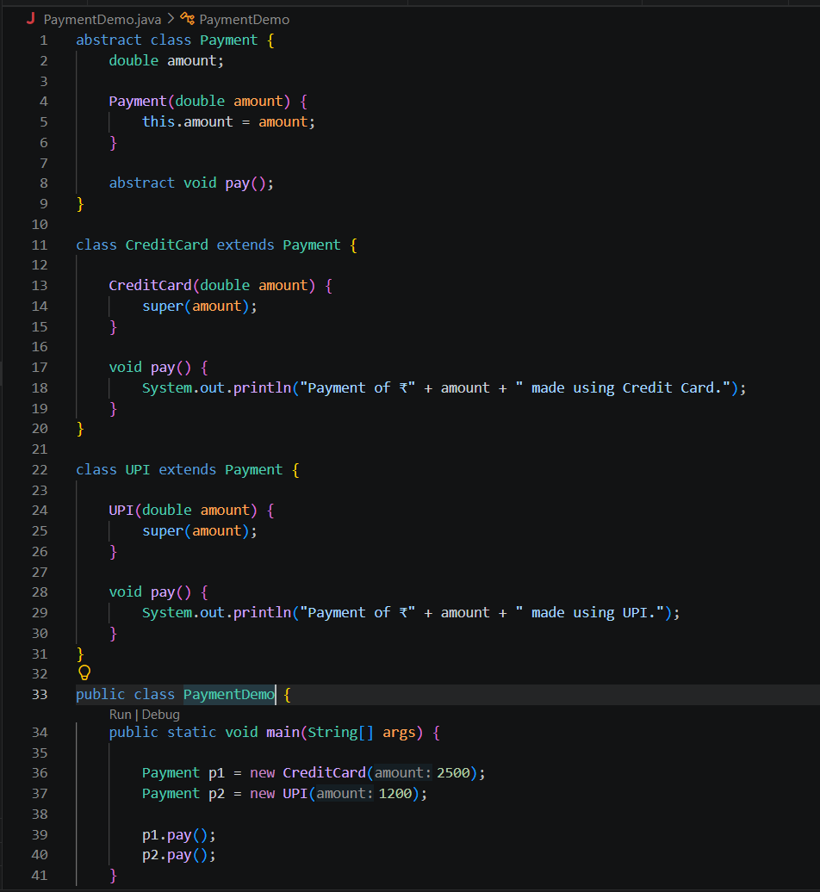
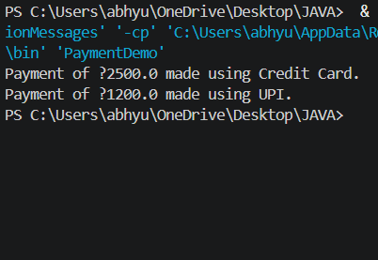
2. Create an abstract FoodOrder class with an abstract method calculateBill(). Implement two subclasses, DineInOrder and TakeAwayOrder, to calculate and display the total bill based on the order type.
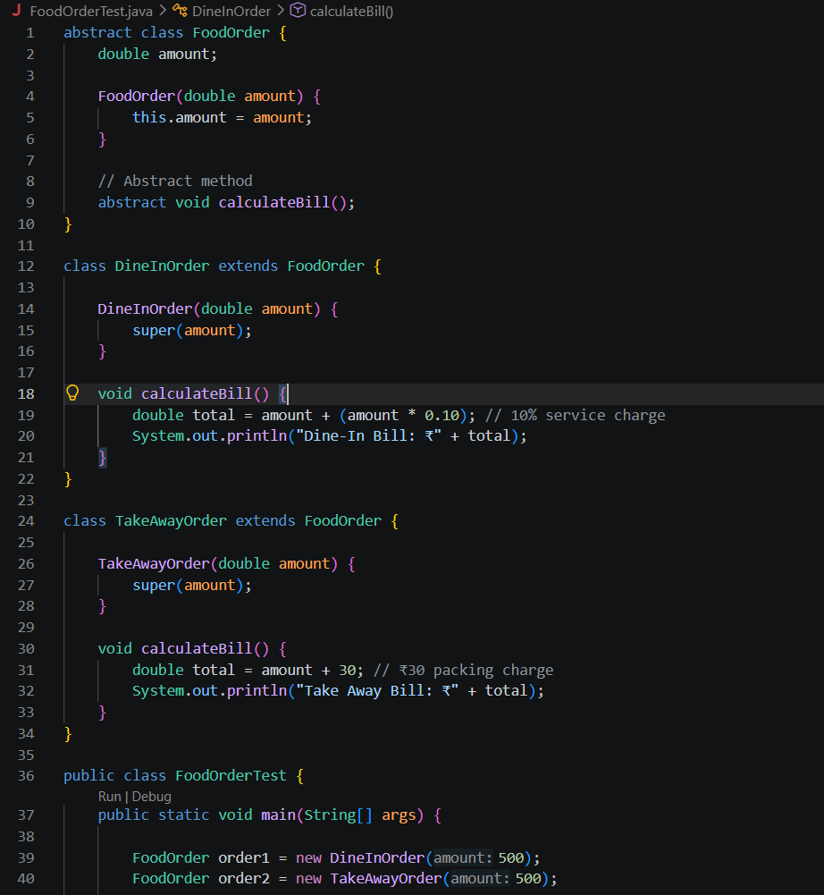
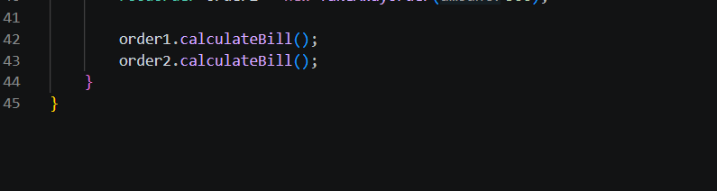
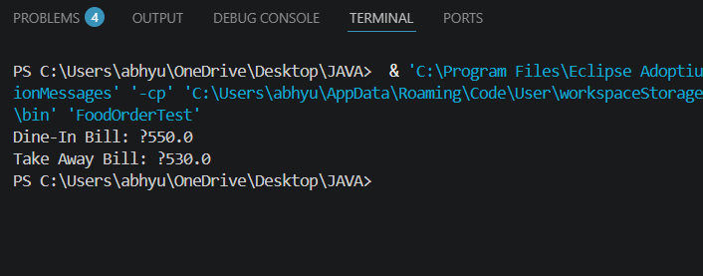
Conclusion:
This assignment successfully demonstrates the use of abstract classes and abstract methods in Java. The Payment and FoodOrder programs show how common functionality can be defined in an abstract class while allowing subclasses to provide their own specific implementations. Abstraction helps hide implementation details, reduces code duplication, and makes programs more flexible, maintainable, and easier to extend.

